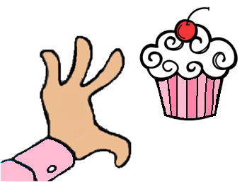
The Cupcakery Café & Bake Shop
HOLIDAY ORDER FORM
All holiday orders are due by close of business on Monday, 12/21. We will do our best to accommodate orders after that, but make no promises (please call for confirmation for late orders). We will have product available in the case all that week for sale outside of special orders. Orders can be faxed to 376-4913, emailed to info@thecupcakery.org, or called in at 784-2253.
Pies | Price | Qty.
Apple | 11.95
Apple Crumb | 12.95
Blueberry | 15.95
Pumpkin | 12.95
Chocolate Cream | 13.95
Coconut Cream | 13.95
Banana Cream | 13.95
NY Style Cheesecake | 27.95
Pumpkin Cheesecake with Gingersnap Crust and Caramel Syrup | 28.95
Key Lime Pie | 13.95
Bourbon Brown Butter Pecan Pie | 17.95

HOLIDAY BASKETS | Price | Qty.
Cookie Creations | 29.99
Macaron Madness | 29.99
Tasty Treats (1/2 size) | 17.99
Tasty Treats (full size) | 32.99

See our website for samples of our holiday themed cakes and cupcakes!
Goodies | Price | Qty.
Whoopie Pies (chocolate, red velvet, oatmeal cream, pumpkin, hot cocoa) | 2.89
Cookies (chocolate chip, pumpkin choc. chip, peanut butter) | 2.49
Decorated Sugar Cookies | 3.49
Gingerbread Cookies | 2.25
Cookie Decorating Kits | 17.99
Assorted Macarons | 1.99
6” Decorated Cake | 19.99
8” Decorated Cake | 24.99
10” Decorated Cake | 29.99
Cupcakes | 2.50
Christmas Cake Pops | 2.49

